AdventureWorks DW 2019 reseller

Tableau visualization and dashboards snapshots

1. What are the sales, discount amounts, product costs, profit, quantity ordered, number of orders & average order size (sales amount) of reseller sales by Product Hierarchy (Category, Subcategory, Model & Product) and ranked by sales?  
   Graphical user interface, application, table

   Description automatically generated
2. What are the sales, discount amounts, product costs, profit, quantity ordered, number of orders & average order size (sales amount) of reseller sales by reseller hierarchy (business type, reseller name)?  
   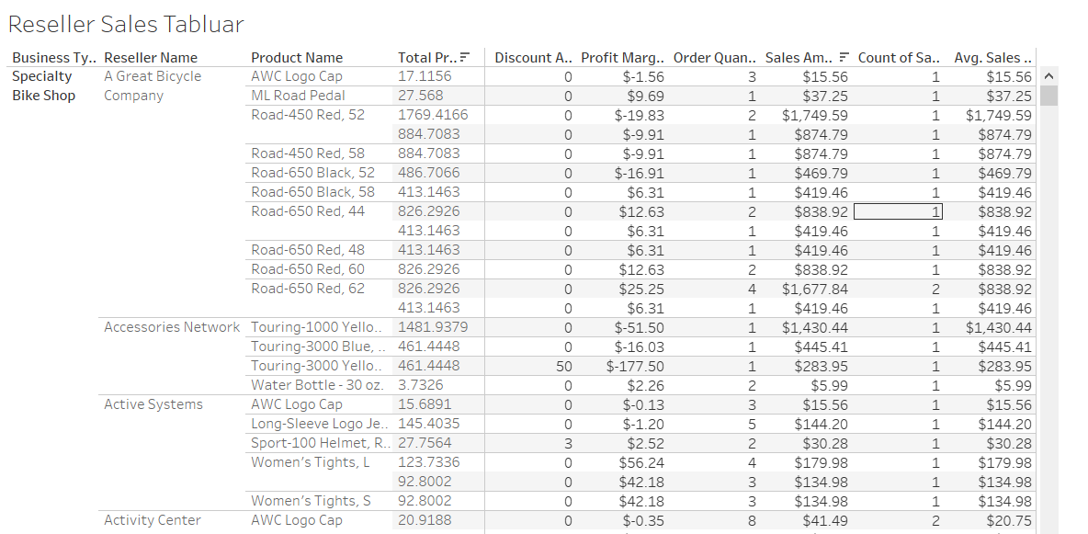
3. What resellers are in the top 10 by sales & profit?  
   Graphical user interface, application

   Description automatically generated  
   Background pattern

   Description automatically generated
4. What are some of the key attributes of resellers (that are tracked by AdventureWorks)?  
   Table

   Description automatically generated
5. What are the sales, discount amounts, product costs, profit, quantity ordered, number of orders & average order size (sales amount) of reseller sales by Geo Hierarchy (Country, State/Province & City of Reseller)?  
   Table

   Description automatically generated with medium confidence
6. Who are the top salespeople?  
   Graphical user interface, application

   Description automatically generated
7. What has been the impact of sales promotions?  
   A picture containing chart

   Description automatically generated
8. Are sales growing overall and what are the sales trends for specific product subcategories?  
   Chart

   Description automatically generated

1. What are the top 10 & bottom product subcategories by sales & profits for bike & accessories?  
   Table

   Description automatically generated Table

   Description automatically generated
2. Product Contribution of Sales  
   Chart, treemap chart

   Description automatically generated
3. Sales Trends & Forecast (by Month)  
   Chart, line chart

   Description automatically generated
4. Sales Promotions & Discounts  
   Table

   Description automatically generated
5. Product Sales by Geo  
   Map

   Description automatically generated
6. Product Profits by Sales Territory  
   Table

   Description automatically generated
7. Top Salespeople ranked  
   Text

   Description automatically generated
8. Top Resellers (Stores) ranked  
   Chart, treemap chart

   Description automatically generated
9. Geo Contribution to Sales  
   Table

   Description automatically generated
10. Salespeople’s report with sales, profit and various person’s attributes  
    Table

    Description automatically generated
11. Resellers’ report with sales, profit and various person’s attributes  
    Table

    Description automatically generated
12. Dashboard Reseller  
    Graphical user interface, application, table

    Description automatically generated
13. Dashboard Product sales  
    Map

    Description automatically generated  
    Treemap chart

    Description automatically generated
14. Dashboard Salespeople  
    Graphical user interface

    Description automatically generated with medium confidence
15. Dashboard Geographic sales (reseller geography)  
    Graphical user interface

    Description automatically generated